ISB Technical Documentation

Capstone 2020 Handover Documentation  
Prepared by: Joshua Want

Contents

Hardware Specifications 3

Parts Used 3

Default Pin out connections for Pi 4

Circuit Design 4

Outputs 4

Software Specifications 5

Basic Page tags 6

# Hardware Specifications

This section outlines the parts used and an overall outline of the electronic design used for the inputs and outputs.

## Parts Used

This list contains the critical components of the ISB. Components which require modification will have details of the modification listed below. It does not list specific part numbers as they are not important. This list may not be exact and depending on individual implementations different parts may be required or parts on this list can be substituted depending on user requirements.

* Raspberry Pi 3 Model B
* 5V 10000mAh Battery Bank
  + 2 USB outputs (1.4A for driving output devices, 2A for Pi)
* 5x 3.5mm audio jack bulkhead connections
* 1x 5V DC USB fan
  + USB plug on end to be replaced with 3.5mm audio jack
* 1x USB A bulkhead connection
* 1x USB A Male to Micro USB male (really short)
* 1x USB A to USB A Cable
* 1x panel mount momentary switch
* 1x USB A male to any
  + Cable cut and positive+negative wires exposed for later use
* Various prototyping wires
* Veroboard
* Lots of 3.5mm stereo cables
  + To be cut and attached to prototyping wires, outputs
* 2-5x small vibration pads
* 4x 5A relay modules (or a 4-in-1 5V relay module, highly advised to simplify wiring lots)
* 2x 3.5mm male to male audio jacks for connecting vibration mat and PowerLink output
* 2x 3.5mm male output switches
  + These can be custom made or store bought if the switch outputs to 3.5mm

## Default Pin out connections for Pi

The below Pinout is the connections used by default in the software (configurable in settings.py). Note that the below pinout refers to the actual pin numbers on the Pi as opposed to the GPIO numbers referenced in settings.py

|  |  |
| --- | --- |
| **Pin** | **Connection** |
| 4 | 5v VCC on relay controller |
| 6 | GND connection relay controller |
| 36 | Primary Switch + |
| 38 | Secondary switch + |
| 34 | Common GND secondary and primary switch |
| 37 | Signal for fan relay |
| 35 | Signal for vibration mat relay |
| 33 | Signal for vibration rotor relay |
| 31 | Signal for Powerlink relay |
| 40 | Shutdown switch + |
| 39 | Shutdown switch - |

## Circuit Design

### Outputs

When designing a circuit for an ISB it is important to understand the different types of output devices that you are attempting to activate, and what style of circuit is needed to achieve the desired effects.

This document will break it down into 2 different categories and provide high overview designs for both

* Power activated devices. These are devices which turn on when supplied with power. Examples of devices such as these include fans and vibration motors.
* Switch activated devices. These are devices which are activated by switches and will have external power sources such as batteries. Examples of devices such as this include switch activated vibration mats, PowerLink boxes.

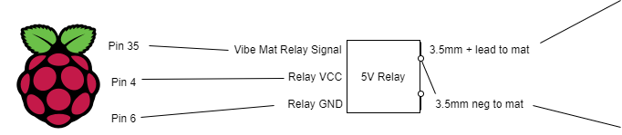

Figure - Design for switch activated devices

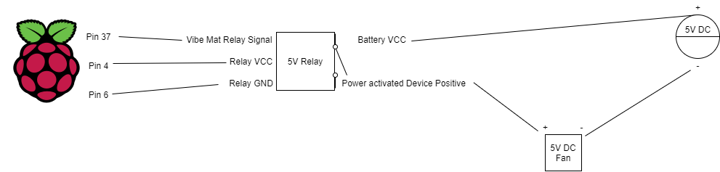

Figure - Design Power activated device

#### Inputs (switches)

Inputs are simple, connect one of the wires coming from the switch to the Pin being used for the switch and the other one to one of the GND pins. The polarity is not important if one of the wires is connected to ground, and the other to a GPIO pin.

# Software Specifications

For expanding of the story all that is required is for a story to be created using JSON formatting, and for any new sounds to be used in the story to be added to the appropriate directory in /assets/.

This section will outline the JSON tags used in the project, by analysing an abridged version of the JSON file used in our implementation. Comments regarding tags will be added below each line if the purpose of a tag is not clear.

## Basic Page tags

[

    {

        "title" : "When the bell plays, press your switch to turn the page",

        "turn_page" : "yes",

Signifies to the game that this page is a “turn page” intermediary page

        "not_random" : "Yes",

Tells the game to not randomise the button order

        "sound_narration" : "turn_page.wav",

Plays this sound file when the page is first loaded

        "buttons" : [

Each page has buttons which also have tags

            {

                "name" : "start",

                "frames" : 4,

Not used anymore

                "image" : "assets/img/buttons/start.png",

Not used anymore

                "location" : [960, 615],

Location that button is drawn

                "text" : "Next page",

Text shown on screen

                "sound_hover" : "next_page.wav",

Sound to play when button is scanned

                "effects": {

Buttons can have effects that happen when pressed

                    "selected_sound" : "page_turn.wav",

Sound played when button selected

                    "not_random" : "Yes"

                }

            }

        ]

    },

    { This will be the next page displayed

        "title" : "My Story is about a",

        "sound_narration" : "story1page1.wav",

        "BeginningOpt1Beg" : "Yes",

The signifies that this is the beginning of the beginning for the 1st story option

        "buttons" : [

            {

                "index": 0,

Gives the number this button is in the list of buttons. Is used to for the word bank. For example if this page had 10 possible buttons, the first button has an index of zero and the last 9. The game randomly picks one index from 0-3, 4-6, and 7-9 to be displayed.

                "frames" : 4,

                "location" : [450, 530],

                "image" : "assets/img/buttons/jetski.png",

                "text" : "Baby",

                "sound_hover" : "baby.wav",

                "effects" : {

                    "selected_sound" : "baby.wav",

                    "output" : ["vibe_mat","custom"]

                }

            },

            {

                "index": 1,

                "frames" : 4,

                "image" : "assets/img/buttons/jetski.png",

                "location" : [450, 530],

                "text" : "Alien",

                "sound_hover" : "alien.wav",

                "effects" : {

                    "selected_sound" : "alien.wav",

                    "output" : ["fan","custom"]

                }

        ]

    },

    {

        "title" : "Press button to move to next page",

        "turn_page" : "yes",

        "not_random" : "Yes",

        "buttons" : [

            {

                "frames" : 4,

                "image" : "assets/img/buttons/start.png",

                "location" : [960, 540],

                "text" : "Next page",

                "sound_hover" : "next_page.wav",

                "effects": {

                    "selected_sound" : "page_turn.wav",

                    "not_random" : "Yes"

                }

            }

        ]

    },

{

        "title" : "So they put on their",

        "sound_narration" : "story1page5.wav",

        "BeginningOpt1End" : "Yes",

This signifies to the game that this is the last page of the beginning option 1. These tags are used to skip the game to the appropriate pages depending on the story combination selected. Each of the 2 options for beginning, middle and end must have these tags for the game to function correctly,

        "buttons" : [

            {

                "index": 0,

                "frames" : 4,

                "location" : [450, 530],

                "image" : "assets/img/buttons/jetski.png",

                "text" : "Coats",

                "sound_hover" : "coats.wav",

                "effects" : {

                    "selected_sound" : "hat.wav",

                    "output" : ["fan"]

                }

            },

            {

                "index": 1,

                "frames" : 4,

                "image" : "assets/img/buttons/jetski.png",

                "location" : [450, 530],

                "text" : "Sunglasses",

                "sound_hover" : "sunglasses.wav",

                "effects" : {

                    "selected_sound" : "sunglasses.wav",

                    "output" : ["fan","custom"]

                }

            }

        ]

    },

At the end of the game there is a readback of the story created. This is represented in the JSON with the follow page. Note, all story sections must have equal lengths, and there must be the same amount of these readback pages as there are in the sum of all 3 sections (e.g. sections are all 5 pages long, there are 3 sections, so we have 15 of these pages at the end)

{ All information except the location is blank, as the game stores the choices students made and auto populates the fields

        "title" : "",

        "playback" : 0,

This is the tag which signifies to the game it has reached the playback portion of the game. The value of the tag is representative of which page the playback is on (so the next page would be 1, then 2, then 3).

        "buttons" : [

            {

                "index": 2,

                "frames" : 4,

                "image" : "",

                "location" : [960, 400],

                "text" : "",

                "sound_hover" : "",

                "effects" : {

                    "selected_sound" : "",

                    "output" : ""

                }

            },

            {

                "index": 2,

                "frames" : 4,

                "image" : "",

                "location" : [960, 600],

                "text" : "",

                "sound_hover" : "",

                "effects" : {

                    "selected_sound" : "",

                    "output" : ""

                }

            }

        ]

    }